Summary

I learnt a lot of new Unix commands and their uses like:

1. The cd command
2. The ls command
3. The mv command
4. The mkdir command
5. The rm command
6. The chmod command with all access groups and options
7. The cp command
8. The grep command
9. The touch command
10. The sudo command

And so on..

The session was very helpful as we got to do hands-on practice along with the theory. I also learnt to navigate in different editors like vim and nano and terminals like git bash and ubuntu.

We started with vim but we could not run all the commands in it so we moved to git bash but chmod was not working in git bash so we finally installed and used ubuntu in which all commands were running successfully.

Initially, writing the commands took some time but after practicing, I could do it easily and could complete all the tasks smoothly.

**SCREENSHOT OF TASKS:**

TASK 1:

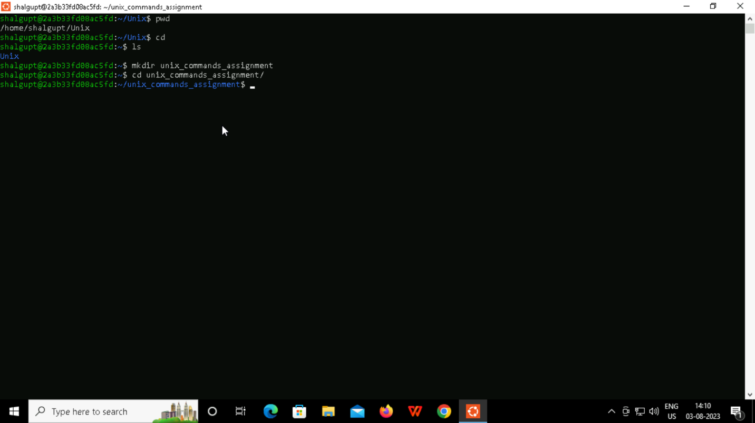

TASK 2:

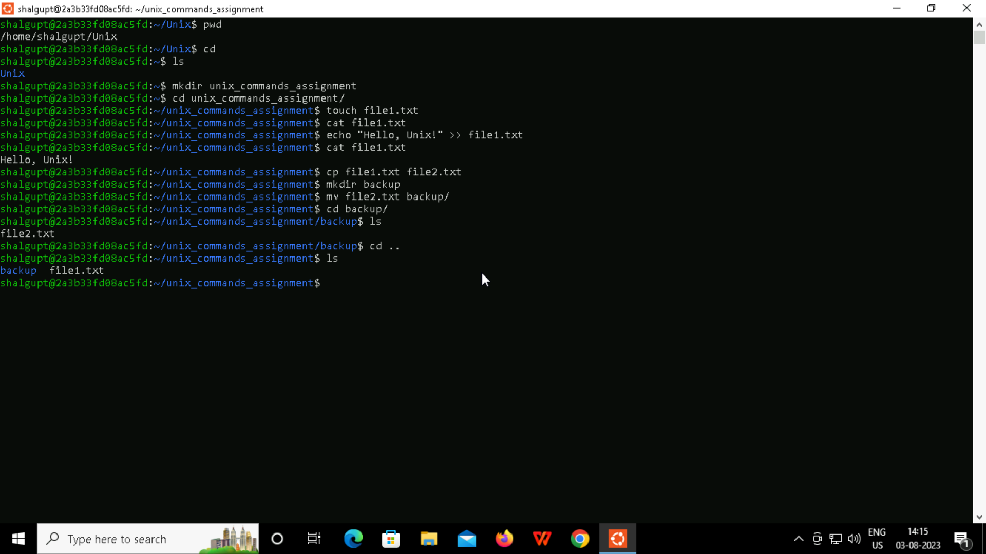

TASK 3:

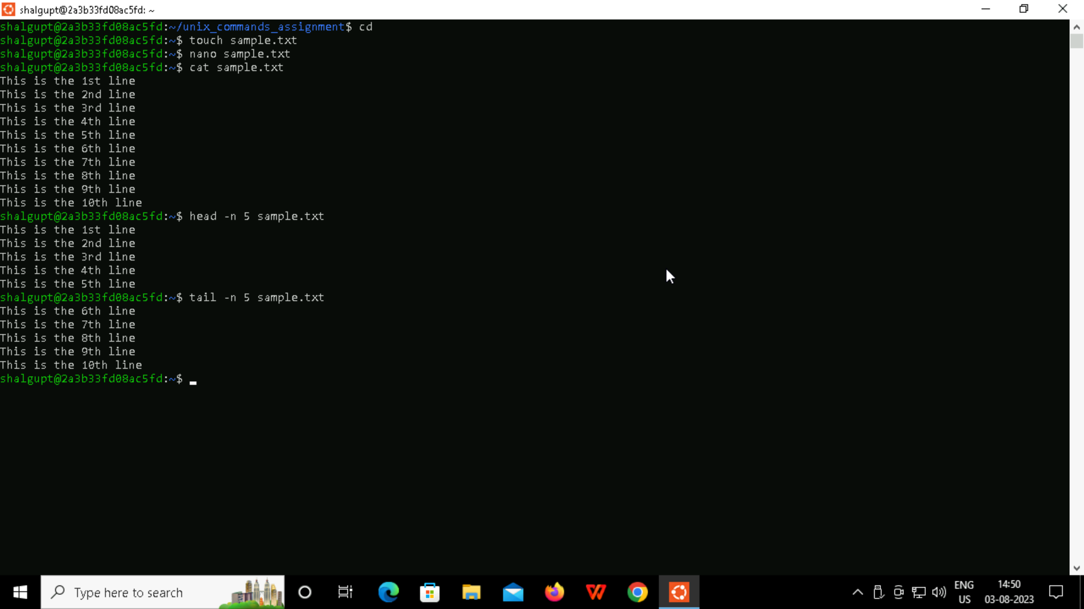

TASK 4:

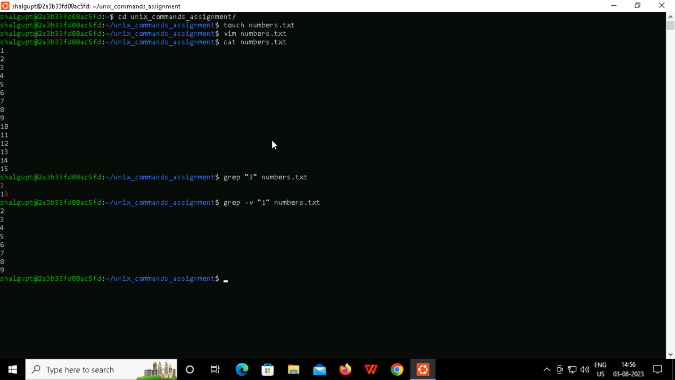

TASK 5:

